**Experimental Design**

The project seeks to explore the actions of agents in a simulated 2D space and investigates what constraints should be placed on their behavior to ensure cooperation. This builds on the ideas discussed in several papers on game theory centered around indirect reciprocity, with the added variables of spatial and hierarchal relationships between peers.

A population of agents will be placed on a grid and each given a preset amount of ‘fitness points’ and programmed with simple rules for how to interact with other agents. They will be able to support each other by increasing the fitness of other agents at a small cost to themselves. An agent can either offer or request support from other agents in its range, and if it receives a support request, can decide to either accept or reject it.

Each agent will maintain a reputation table listing each other agent and their reputation score. They will use this information to decide whether to support other agents. Agents who are in close proximity to a pair of agents engaging in an interaction will be able to observe this interaction and update their reputation tables accordingly.

The agents in each instance of a game will be in a ‘hierarchy’. Agents higher up in the hierarchy will be rarer and will have the ability to give all agents lower in the hierarchy ‘commands’ which the agents will be able to either accept or reject based on the reputation of the agent giving them. These commands will include to support the agent giving the command, to change their reputation tables, or to otherwise change their behavior. Experimentation will explore different sets of commands and their effectiveness.

Agents will also be able to ‘gossip’ – spread information about their own reputation tables to other agents. This information can be either truthful, or not, and can include information about themselves. Whether an agent believes this ‘gossip’ will also depend on the gossiper’s reputation. Through this mechanism, each agent will be acting with imperfect information.

Each agent will have its own ‘strategy’, defined by –

* How it decides when to request, offer and agree to give support
* How it assigns a reputation to its peers based on its observations
* How it decides whether or not to give support upon request
* How likely it is to gossip, and its propensity to lie
* How it decides when to give commands to agents lower on the hierarchy

The actions an agent will actively take will be limited to

* Navigating the shared space
* Sending gossip messages
* Requesting assistance
* Offering assistance freely
* Giving a command

Giving support upon request and observing interactions will happen passively.

The agents will learn through a genetic algorithm based on their fitness, so that the strategies which lead to the greatest fitness overall.

Nowak & Sigmund (2005) describes models of indirect reciprocity which are evolutionarily stable under certain conditions. These models will form the basis for the rules governing the first generation of agents, and their stability in this new more complex model of interaction will be tested.

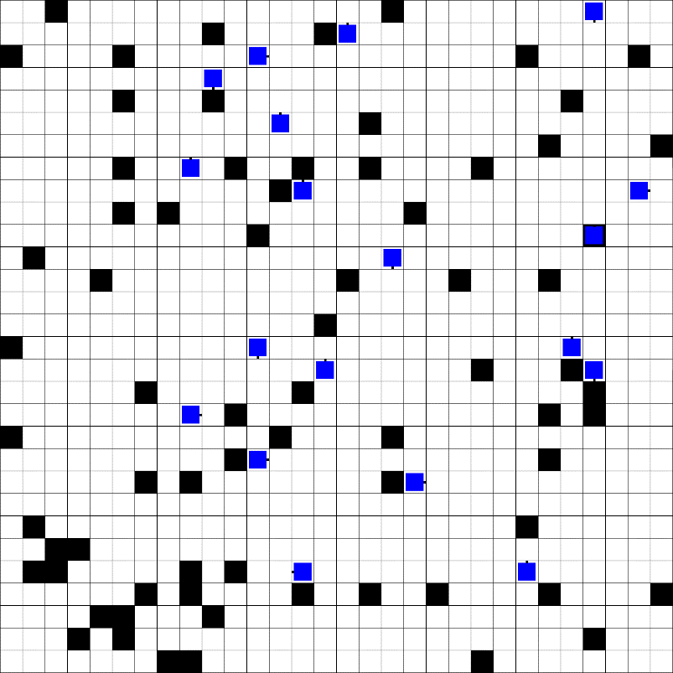

Fig. 1: Typical environment, with the blue symbols representing agents, and the black squares representing food

The questions I am trying to answer include:

* **Does an altruistic strategy exist under this model which is stable even with mutations enabled?**
* What role does ‘lying’ have in indirect reciprocity? Can agents make use of gossip even when it may be misleading or intentionally false
* What potential selfish strategies exist to undermine reciprocity?
* Can the properties of the model itself be varied to cause one stable altruistic strategy?

Questions the hierarchical model will attempt to investigate/answer:

* **Can stable models of indirect reciprocity still exist when agents do not have equal opportunities?**
* Will high ranking agents have higher average fitness?
* Will agents on different levels be naturally drawn to cooperate or compete?
* Is it in the best interest of the higher up agents to act selfishly or not? Lower level agents outnumber them, so it might be more profitable to raise their reputation through altruistic acts than to exploit them

**World description**

30x30 grid with 100 agents on it. At the start of the session, every agent is placed in a random position on the grid. Every frame, each agent moves in a random direction. Then, each agent selects a random other agent in a 5x5 radius and decides based on some internal rule whether to give them ‘points’ or not based on its ‘reputation’ – a score indicating whether any one agent is considered ‘good’ or ‘bad’. Each agent maintains its own reputation table. When a transaction occurs, all agents within a 5x5 radius of the agent which initiated the transaction will update their opinions of that agent, again based on some internal rule which takes into account both the donor and the recipient.

After a set number of frames, each agent’s fitness will be evaluated based on the number of ‘points’ they have accumulated from their transactions. These fitness values will be fed into a genetic algorithm which generates 100 new strategies for the next cohort of agents.

**First Experiment description**

Set up a world with the specified parameters, with random starting strategies. Run it for a set number of generations, optimizing the strategies based on fitness each generation.

**Hypotheses**

The ‘leading eight’ strategies discovered by Ohtsuki and Iwasa (2004), which take into account the reputations of both donor and recipient when assigning reputation scores, do not remain stable in this model.

3 worlds

Original paper world

That world with gird

That world with gossip

+detail, why a grid + references

+ grid

Strategy representation

Stability in evolutionary mechanics

Visualize strategies ??

Test out agent languages (erina paper)

Cost of spatial movement

language: Erina

language: Mason

language: Repast

language:

Agent simulators

List of things to do for next meeting: